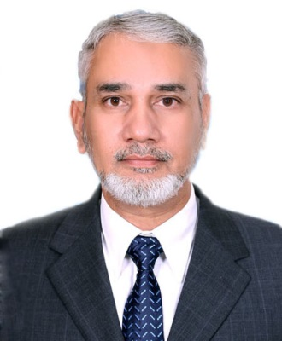

**CURRICULAM VITAE**

**Feroz Akbar**

Address: IH – 24 Street # 06 AFOHS Falcon Complex New Malir Karachi Pakistan

Phone: 0092-3205500356

Email: ferozakbar@yahoo.com

**Objective:**

Seasoned engineering professional with extensive administrative and managerial experience, seeking the Chief Executive Officer position at Karachi Tools, Dies & Moulds Centre to leverage over 27 years of expertise in the engineering industry, leadership, and project management.

**Qualifications:**

- BE (Aerospace Engineering) - NED, 1987 (College of Aeronautical Engineering)

- BSc (Hon) (War Studies) - Karachi University, 2003 (PAF Air War College)

- MS (Engineering Management) - PAF KIET, 2019

- MBA - PAF KIET, 2023

**Professional Experience:**

**Pakistan Air Force**

***Group Captain (Colonel) - Retired***

***Engineering Branch (27+ years)***

- Managed large-scale engineering projects, including the supervision of dye and mould designing and manufacturing.

- Oversaw the maintenance and repair of aircraft and Ground Support Equipment (GSE).

- Led an aeronautical technical school, managing training for local and international trainees in aerospace maintenance.

- Conducted quality control, quality assurance, and flight safety measures.

- Executed project management tasks, including the sale of aircraft to the Kingdom of ***Saudi Arabia.***

- Supervised production planning and control for aviation parts manufacturing.

***Additional Director Technical and GSE at HO SAPS JIAP Karachi***

- Handled procurement and maintenance of aviation GHE.

- Management and supervision of overall engineering activity at Shaheen Airport Services at HO, SAPS, JIAP Karachi.

- Managed audits and evaluations of engineering training and security infrastructure setups.

**Teaching Experience:**

- Visiting Lecturer at PAF KIET (since 2020 till 2021)

- Lecturer at PAF KIET (since 2021 till date)

**Skills:**

- Strong leadership and strategic direction.

- Extensive experience in project management, particularly in engineering and manufacturing.

- Proficient in managing technical teams and communicating effectively with stakeholders.

- Skilled in quality control, quality assurance, and technical investigations.

- Skilled in Engineering audit.

- Expertise in the procurement and maintenance of aviation equipment.

**Courses & Certifications:**

- Six-Sigma (PIMS Karachi)

- Statistical Quality Control (CAE Risalpur)

- ISO 9000 Quality Management and Internal Auditing (PAC Kamra)

- Project Management (CAE Risalpur)

**Publications:**

1. “Investigating the Effects of Workplace Bullying on Employee's Proactive Safety Behavior: Exploring the Mediating Role of Emotional Exhaustion”, KASBIT BUSINESS JOURNAL, Year 2023.
2. “The Moderating role of commitment to management and mediating effect of Green Organizational Citizenship Behavior on the relation between green supply chains Practices and organizational performance of freight forwarding industry of Malaysia”, THE ASIAN BULLETIN OF GREEN MANAGEMENT AND CIRCULAR ECONOMIES, Year 2023.
3. “How Attitudes Translate to Brand Loyalty: Examining the Antecedents and Consequences of Attitudinal and Behavioral Brand Loyalty”, Propel Journal of Academic Research (PJAR), Year 2022.

**Awards:**

- Professional Excellence Badge

- Chief of Air Staff Commendation Certificate (twice)

- Letter of Appreciation (KFAA Riyadh, Saudi Arabia)

**Professional Affiliations:**

- Member of the Royal Aeronautical Society Pakistan

- Member of the Institute of Engineers Pakistan

**Other Interests:**

- Golf

- Squash

- Cricket