Dated: 26th July, 2024

The Company Secretary,

Karachi Tools, Dies & Moulds Centre,

Sector No 38, NC No 24, Korangi Creek Industrial Park, Korangi Creek,

Industrial Area, Korangi Creek Road, Karachi.

**Sub: Application for the post of Chief Executive Officer**

Dear Sir,

This is in response to the advertisement that appeared in DAWN of July 7th, 2024 for the position of CEO of Karachi Tools, Dies and Moulds Centre (KTDMC) for which I seek to express my interest as a candidate for the advertised position.

By way of brief introduction, my terminal educational degree is from University of Illinois at Urbana Champaign, one of the top universities in USA. From that institution I earned Masters’ in Business Administration (MBA) in Engineering Management and Corporate Finance in 1995. Earlier, I obtained my BSc (Mechanical Engineering) degree from the University of Engineering & Technology, Lahore in 1991. Since 1995, I have hands on experience in the working and management of engineering and production companies as well as policy making, financial and technical advisory in top private and public sector enterprises.

As the attached CV shows, in the recent past, I was the CEO and Managing Director of National Fertilizer Corporation of Pakistan (NFC), a 500 employees company under the Ministry of Industries and Production, which gave me the challenge to turn around NFC and various entities owned by it such as National Fertilizer Marketing Company Ltd, NFC-Institute of Engineering and Fertilizer Research, NFC Employees Welfare Foundation, and NFC Employees Cooperative Housing Society. During my tenure, I had incorporated public private partnerships and propelled up the profitability through cost controls and institutional reforms. I had advised the management of Pakistan Machine Tools Factory, Karachi in improving their financial obligations and address their business development challenges by inspecting their facilities and providing technical advice to achieve their production targets. In addition to my work for NFC, I was tasked with formulating recommendations for restructuring and setting performance indicators for 35 entities/organizations including KTDMC under the Ministry of Industries and Production, to systematically promote efficiency, effectiveness and growth in these organization. In appreciation of my professional approach, exhaustive technical report and consequent improved performance of those entities, Ministry of Industries and Production (MoIP) granted a Letter of Commendation to me.

Summing up, I am a result-oriented professional, with an ambition and acumen to provide highly effective corporate leadership. I do strongly feel that I can provide the desired leadership to turn this engineering and production company into a profitable concern as per vision and policy of the Board of KTDMC.

I am confident that you will find my career profile and CV of particular interest and in line with the job requirements of the advertised position. If allowed, I plan to give a short but concise presentation of ten minutes on my strategy and short term –medium term plan to turn around KTDMC. I look forward to be short listed for an interview to discuss in detail my suitability and merit for the advertised position.

Yours truly,

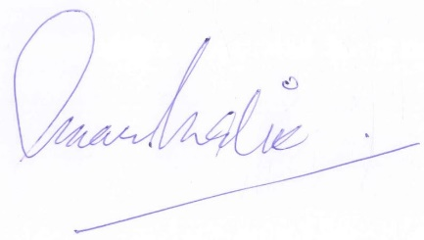

Engr. Omar Saeed Malik

22-A, Askari Scheme 1, Chaklala Scheme III,

Rawalpindi Cantt.

Phone/ Cell: 0300 8555234

Enclosure(s): 1- Curriculum Vitae

2- Copies of testimonials

3- Photograph and CNIC